**Crew Daily Safety Rating**

When Jim Burns, the creator of the Positive Attitude Safety System, started consulting in 1985, the basic reporting Safety measurements were: Fatalities, Lost Time Accidents (LTAs), Incident Reports and Near Misses. There were basically four different levels of reporting, and this allowed easy comparisons of safety data between the various operations and companies. The Safety Pyramid was the foundation for these levels and illustrated a statistical relationship between the levels. Over the decades, the pyramid has evolved but has been disregarded by many safety professionals and organizations. We (at PASS Inc.) suspect that the validity of the pyramid has been eroded by a lack of accuracy or honesty in reporting. Today, safety specialists report safety data in many distinct ways.

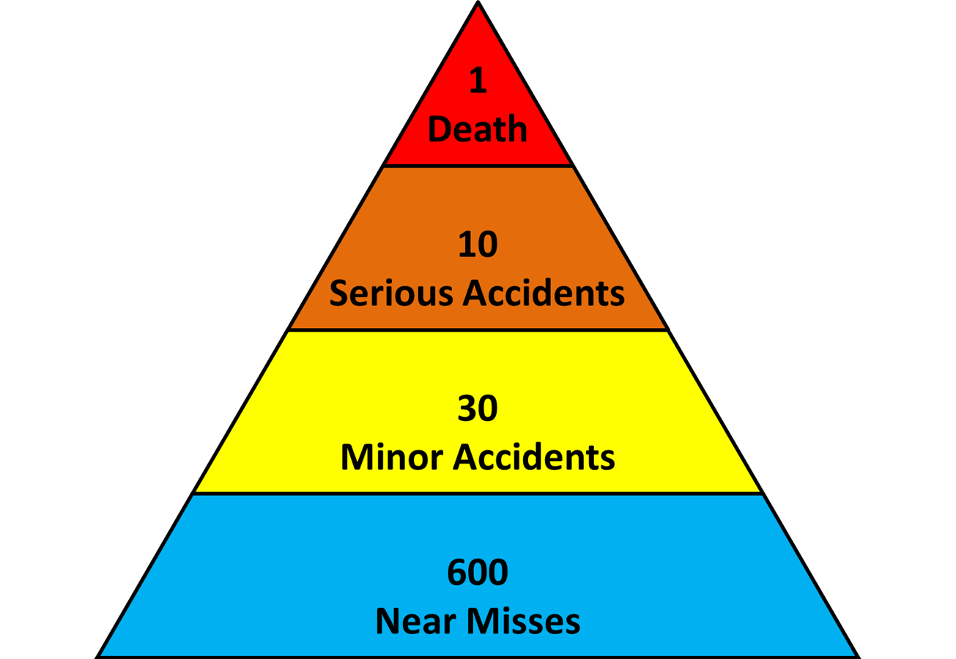

Some of the safety performance indicators we now talk about are: LTIFR (lost time injury frequency rates), DISR (disabling injury severity rates), TRIFR (total recordable injury frequency rate), AIFR (all injury frequency rate), CIFR (classified injury frequency rate) and PFI (frequency of potentially fatal incidents). In addition, there are many lagging and leading safety indicators, SMMs (safety maturity models) and various Safety Awards, such as the Sentinels of Safety Award and the John T. Ryan Award.

We believe that significant changes in safety reporting occurred when the larger mining companies moved from Lost Time Accidents (where the employee could not report for any portion of the next scheduled shift) to Classified Injuries (where the employee was unable to perform their normal duties and activities). This, and many other significant changes in reporting safety data, has resulted in the inability to perform longitudinal comparisons. The purpose of this essay is not to discuss the changes and improvements to traditional reporting systems but to acknowledge these adjustments over the past 35 years. The question that needs to be addressed is whether these safety statistics impact or influence the daily safety performance of the shop floor employees. We strongly suggest the need for the crew members to have their own safety rating system to promote daily safety improvements.

When we discuss safety in terms of daily safety objectives (and how and who records them), it is critical that we understand and focus on the impact of these ratings on the crew. We would argue that the crew members are very interested in whether and how they met their objective of having a safe day during the previous shift. However, more importantly, can we use yesterday’s results to motivate them to be safe and improve the safety of the commencing shift? Broad goals such as ‘Zero Harm’ are excellent; however, they need to be broken down into shift-by-shift objectives.

Professionals agree that the objectives need to be specific, attainable and measurable. In addition, these ratings need to be honest, relevant, realistic and agreed upon (crew-based rating); but most importantly, a new positive rating (for when they made their shift safer). This is a significant move from default measurements (e.g. how many days since the last lost time accident) and has the crews tracking their Safety in a Positive and Proactive manner.

Total Quality Management says that ‘quality’ can be determined only by the customer. The customers in safety are the employees who are putting their hands, arms and bodies in danger during every shift. So, it is only logical that we have every crew record and track their crew-defined safety rating for each shift.

Therefore, we need to implement a simple system that is sustainable and self-refreshing. Safety ratings are dynamic, so the system needs to evolve and develop over the months and years. We start by simply asking the crew whether they had a safe shift. This first question asks, “Did ‘you’ have a safe shift yesterday?” When introducing this PASS Component, I always receive the following responses: we are all here; no one has been hurt; and/or, no one reported an incident. This is the basic, classic and ingrained mindset of judging safety by default measurements. We need to move away from the ‘reporting mindset’ and start discussing safety in terms of Safety behaviours, then decision-making and finally attitudes. This, of course, means we cannot just have a binary rating (the old pass or fail). We need a quality rating that highlights shifts where the crews improved safety.

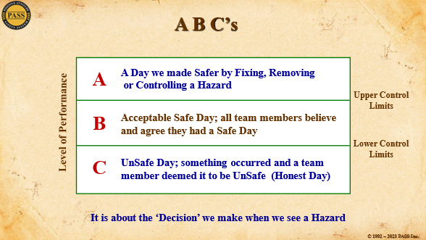To achieve this, we propose a safety rating of A, B or C Days and the crews report their safety improvements as A Days. These A’s are kept in their A Logs (another PASS Component). Over time, the rating will evolve with the crews’ values and understanding of what Safety truly means. They will be constantly discussing and accessing their ABC safety ratings (‘storming and norming’). This will particularly become interesting when they start addressing their proactive A’s and when they start to track safety beyond work. This rating process is “Simple in its Sophistication.”

A thumbnail summary of the crews’ journey of understanding the A, B and C’s: At first, the crews give themselves an A for removing, controlling or eliminating a hazard. These hazards are often ‘Transient’ hazards (only there for a portion of their shift) or part of a ‘Swiss cheese’ scenario. The crews realize that when they see a hazard, they have a decision to make. If they address the hazard it will result in an A Day. If they do nothing, then it will be a C Day. Obviously, it takes some time before the crew members become comfortable giving themselves C’s and explaining and discussing the reasons why. In the next stage, individuals begin to realize that things which were ‘deemed to be safe’ can be made safer and this becomes their new rationale for A Days. Eventually, they move to the attitudinal stage where they are constantly looking for opportunities to improve safety (continuous improvement) whether at work, at home or in the community. They are no longer just talking about the previous shift but about how they can have a ‘proactive A’ regarding the commencing shift’s activities.

The foundations for these ratings will progress from behaviour-based, to decision-making and ultimately to attitudes of Continuous Improvement. This final attitudinal stage we call the SupLex® Safety Culture.

***“SupLex®*** *is a series of Decisions and Actions that are initiated by a person who has a Positive Attitude to constantly make things Safer.”*

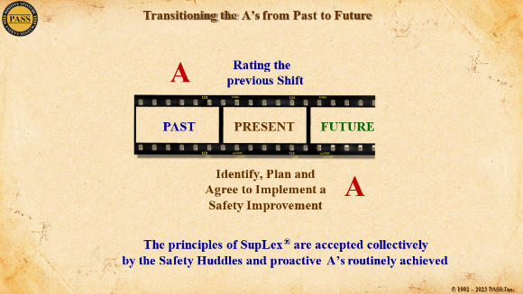

*A worker’s* ***SupLex®******Attitude*** *is evident when the worker comes to work every day with the objective of, “I am going to make it safer for myself; my fellow workers; and/or leave it safer for my cross shift.”*

*A* ***SupLex®*** *Safety Culture within an organization has sufficient personnel with SupLex® Attitudes and has their ‘Work Teams’ identify Safety Improvements. Every shift, their teams complete, or make progress on, at least one safety improvement.*

*As a result of the* ***SupLex®****mindset, every member of the organization looks for any opportunity to embrace the principles of Continuous Improvement in order to make their workplace Safer. This progressive Safety Mindset will go beyond the work site, into their Homes and Communities; therefore, benefiting their Families and Neighbours*

Thank you for your time and attention and I hope you find this essay informative and thought-provoking. Please keep in mind that the above is a simple summary of the PASS reporting component called, Safe Day Charts.

Make it a Safer Day,

*James S. Burns*

President and Safety Architect

Creator of the Intellectual Property known as **PASS**

Founder of Positive Attitude Safety System Inc.

**1490 Appleridge Road, Toll Free: 1.800.764.1628 Phone: 1.250.764.1190**

**Kelowna, BC Canada V1W 3A5 Mobile Canada: 1.250.878.2746**

[**jburns@passinc.net**](mailto:jburns@passinc.net) **© 2024 Positive Attitude Safety System Inc.** [**www.passglobalinc.net**](http://www.passglobalinc.net)