**A Logs: an excellent opportunity for positive reinforcement**

When embarking on an implementation journey to establish a positive and proactive safety culture of continuous improvement, you need positive reinforcement to be the driving force at all levels of maturity. The A Logs are an excellent and effective way of ensuring this happens.

This positive reinforcement needs to come from peers (fellow crew members) and line management. It must be perceived by the crews for relevant safety events, and this positive reinforcement must be delivered consistently. How does Line Management identify what are the relevant safety events/improvements and which crews or individual crew members they should provide positive reinforcement to? It would make sense to have a system where the crews tell us when they improved Safety, even when they are not present. The first step is for the crews to have their Safety Huddle, rate their previous shift and then put their rating on their Safe Day Chart. If the crew had an A Day, they need to enter the reason for the A in their A Log (the supervisor ensures this happens). One critical point is that the A Logs are only for A’s and not B’s or C’s. If the C is a significant hazard or unsafe act, it needs to be reported through their traditional safety system. Please note that their supervisor is always present in the Safety Huddle, and one of their duties is to ensure that the appropriate things are reported through the traditional system.

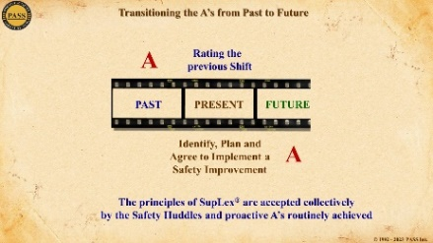The A Logs make it easy to see how the different types of A’s evolve over months and years. The initial reasons for the A Days are for hazard removal. Then, for making things ‘Safer’ that have been deemed to be safe. Later, they share their A’s from their days off and from their activities in their homes and their communities. Ultimately, the crews are no longer just talking about A’s from the previous shifts but now plan and implement safety improvements for the commencing shift which are proactive A’s.

The other important progression is when their safety discussions are not just about behaviour (“I removed a hazard”) but about decision-making: “When I spotted a hazard, I stopped what I was doing to address the hazard, even though it was not my responsibility.” The simple difference between an A and a C is the decision you make regarding the hazard. So, the objective is to have all the crews constantly looking for hazards, addressing them (A Day) and ensuring they receive positive reinforcement.

The final maturity stage is when we have embraced the attitude of continuous improvement in safety. The crew desires to have an A Day every shift (Kaizen - daily constant improvements). We call this a SupLex® Attitude, which is when employees come to work every day with the objective of, “I am going to make it safer for myself, my fellow workers and/or leave it safer for my cross shift.”

There are more sophisticated ways of evaluating the A’s, such as the difficulty of the A (involving other crews, etc.), moving from ‘interim’ fixes to ‘corrective’ fixes, and systematizing the A’s through better procedures or training manuals, etc.

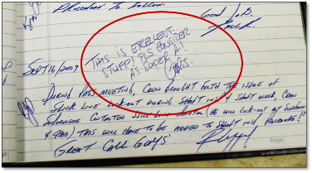Therefore, how does this system of positive reinforcement work? When Line Management sees an A on the crews’ Safe Day Charts, they should read the A Log entry for the day (their A Logs are to be kept with the Safe Day Chart). There are basically three levels of positive reinforcement concerning the A’s. The first step is to initial the entry (this shows you read the A Log) and, for more ‘solid’ A’s, write a short positive comment. This can be in the margin or just below the entry.

For a significant A, in addition to writing a comment, ensure you provide positive reinforcement to those involved. This can be done in person later in the worksite, in the lunchroom, in the camp/community, on the radio or even in an email (and copied to key personnel). The point is that the crews can see that Line Management is paying attention to their A’s, that they appreciate the crews’ efforts and that the crew or crew member(s) will receive positive reinforcement for improving Safety. Therefore, this feedback loop will encourage, motivate and reinforce the crews’ improvements and lead to the maturing of the reasons for their A’s.

There is a key opportunity to improve operational safety when line management reads the reasons for the crews’ A’s. While reading the A Logs, Line Management should be thinking: Can I improve it? Can I expand it? and/or Can I systematize it? This approach creates an opportunity for expansion of the Crews’ A’s by line management. However, how can we sustain and ensure that this happens daily? First, each level of line management should conduct the Report Down System, which requires them to know, collect and display the crews’ ratings in their area of responsibility. To ensure and reinforce these activities, line management has its own daily Huddles, called SupLex® Huddles, with their peers and superior. Both the Report Down System and SupLex® Huddle will be explained and summarized in future essays.

When the crew and line management are working together on daily safety improvements, they create a **SupLex®** Safety Culture. The SupLex® Safety Culture is an organization which has sufficient personnel with SupLex® Attitudes and where their Huddles actively identify Safety Improvements. Every shift, their teams complete, or make progress on, at least one safety improvement.

I will end by saying it is easy to audit and summarize the number of the crews’ A’s and the number of initials and comments from Line Management. Below are examples from two different mines. The first example shows just the Crews’ A’s (1107 A’s) and the second example shows the number of A’s plus Initials and Comments. Both Mines have a Positive and Proactive Safety Culture of Continuous Improvement.



Thank you for your time and attention and I hope you find this essay informative and thought-provoking. Please keep in mind that the above is a simple summary of the PASS component called A Logs.

Make it a Safer Day,

*******James S. Burns*

President and Safety Architect

Creator of the Intellectual Property known as **PASS**

Founder of Positive Attitude Safety System Inc.

**1490 Appleridge Road, Toll Free: 1.800.764.1628 Phone: 1.250.764.1190**

**Kelowna, BC Canada V1W 3A5 Mobile Canada: 1.250.878.2746**

[**jburns@passinc.net**](mailto:jburns@passinc.net) **© 2024 Positive Attitude Safety System Inc.** [**www.passglobalinc.net**](http://www.passglobalinc.net)