**Report Down System: Checks and Balances of the PASS System**

When embarking on an implementation journey to establish a positive and proactive safety culture of continuous improvement, you need positive reinforcement to be the driving and cementing force at all stages of maturity. The A Log component is an excellent and effective opportunity for positive reinforcement and the Report Down System is a component that supports the delivery of this vital and timely positive reinforcement. However, we need to ensure that line management is consistently engaged in their important role of reinforcing Safety (especially the crews’ A’s); hence, the Report Down System is an essential component to the overall integration of the PASS Components.

The reasons why this component is important:

* It is essential that line management makes it a point to visit their area of responsibility, and personally check and collect the Crews’ ratings from their Safe Day Charts. They should not be waiting for their reports to provide them with the information. The ratings are so important that line management should check the Safe Day Charts themselves.
* By completing the Report Down System activity, line management clearly demonstrates the importance of the Safe Day Charts’ ratings and the crews’ entries in the A Logs.
* When there is an A on the Safe Day Charts, line management must read (and hopefully be seen to read) their crews’ A Logs.
* Line management should always initial, comment and/or follow up with the person(s) responsible for creating the A. This also creates an opportunity to provide positive reinforcement to the crew’s supervisor.
* It is critical for line management to consider if the crew’s A could be Improved, Expanded and/or Systemized.
* Providing positive reinforcement during the Report Down System can serve as an example of the “who they thanked for Safety” question for their SupLex® Huddle. (Which I will discuss in another essay).

**The Mechanics of the Report Down System**

It is expected that the second level of line management (Superintendent or General Foreman) will daily collect the Crews’ ratings (usually they write it down on a piece of paper) and then transfer the scores to their Report Down System Chart. So, the superintendents look at their Crews’ Safe Day Charts (reading the A Log when appropriate) and place the crews’ Safe Day Chart rating (A, B or C) in the appropriate square. The top line will represent the overall crews’ rating of Safety in the Superintendent’s area. This method of rating follows the same guidelines as the daily Safety Huddle rating. If one Huddle member has a ‘C’ then the entire Huddle has a C; if all ‘B’s’ then the Huddle scores a ‘B’; and if someone has an ‘A’ and the rest are ‘B’s’ then they have an ‘A’ Day.

**Super A’s**

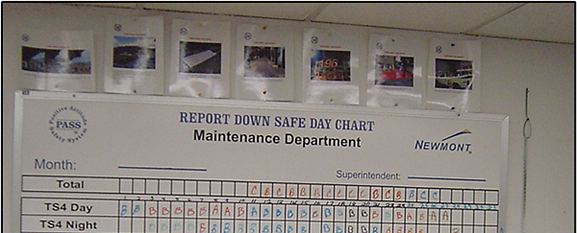

The example above shows the rating with an A* to indicate a ‘Super A’ Day, which is an A the crew considers important. It is suggested that they take a picture of the A and place it on a poster with a brief explanation. These Super A’s can be placed on the walls, on a clipboard or above the Report Down System chart.

**Banked A’s**

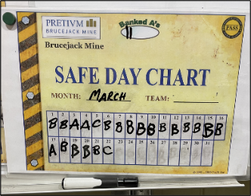Banked A’s are when the crew has a C Day but someone also improved Safety (A Day) they put the C in the square and a slash in the Banked A circle. The C overrides the A; however, we do not want to lose the A (safety improvement) hence the Banked A. Also, if they have two A’s on one day, one A goes in the box and the second is a Banked A. The reason for this is that the Banked A must always be entered into their A Log. Line management now has an opportunity to positively reinforce the A and consider if the A can be improved, expanded or systemized.

**So, if one crew in the superintendent area has a C, then their entire area is scored as a C Day. If all B’s then a B Day, and if an A and all B’s then an A Day. However, we want to capture the crews’ Banked A’s on line management’s Report Down System chart. It is also interesting to discuss with the crew, their rating rationale when they have a C that later becomes an A. I slipped on the ice outside the shop (C) and put some sand down on the ice (A). Hence, a discussion on the different types of A’s (a reactive A vs. a proactive A).

The same process is followed by the Manager, the manager checks the superintendents’ charts and fills in the Report Down System Chart for the Mine department. The simple example to the right illustrates a mine manager who has three superintendents. If one superintendent has a C Day the Mine Department rates themselves as having a C Day.

The Report Down System charts tend to be plasticized or laminated and posted on the door of the Superintendents and Managers using Velcro. In the next example, you can see the Report Down System Chart on the manager’s door showing the crews’ rating and not the superintendents. This demonstrates that the Mill Manager Simon goes out to the Mill’s control every day and collects the Crews Safe Day Chart rating himself. Of course, if an ‘A’ on a Safe Day Chart, Simon addresses the crew’s A Log appropriately. Please note that Simon puts a little crib note by the A’s on his chart.

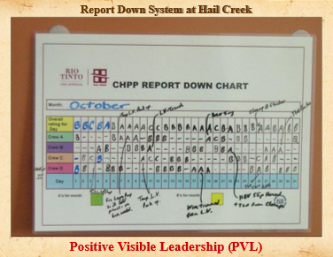At first, this procedure is very regimented but over time the manner is less important; however, the technique of positive reinforcement becomes paramount. Line management assists the crews in ‘shaping’ their reasons for their A’s by their initials or comments in the A Logs. Therefore, introducing the various types of A that the crew should be considering. These A’s can be reactive, proactive, on days off, at home or in the community, created by working with their cross-shift, interdepartmental A’s, expanding and improving an A among the crews, etc.

The size of the organization, shift rotations, and location of the operation can be challenging; however, there are various ways of addressing these situations. At Newmont’s large Carlin Nevada Operations, we had two large maintenance shops, so we had to update two large Report Down System Boards which were many miles apart. Today we can easily record and share information with our cell phone cameras; however, it is critical we keep the ‘ratings’ on these boards up to date. In this operation, we trained an expeditor to be a PASS Leader and he kept the Report Down System Board up to date as he visited all the maintenance areas/shops every day. Please note they had a box at the lower right that had the running total of A’s for the month (69 A’s) and the Banked A’s are in the bottom left-hand corner.

**The Checks and Balances**

Ensuring that the charts are completed in a timely fashion every day: Obviously, the Manager’s Chart cannot be filled until the Superintendents have checked on the crews’ Safe Day Charts and filled in their Report Down System Chart. When I first implemented this at the Sullivan Mine in the 1980s, the mine manager, Jim Greenhalgh, would check the charts first thing in the morning; therefore, everyone had their charts completed and positive reinforcement had already been given when appropriate.

We need to ensure that all the Safe Day Chart ratings are collected and the A’s are addressed appropriately through the A Logs. The validity of the A’s can be audited by comparing the number of A Days collected through the Report Down System and the number of A’s contained in the A Logs. So, if the number of A’s from the Report Down System and the number of A’s in the A Logs do not reconcile, we can have several issues.

Fewer A’s in the A Logs than on the Report Down System boards:

* The A’s are being reported on the Safe Day Chart and into the Report Down System but the crew(s) is not entering them into the A Logs. This could be a sign that the crews do not understand the A Logs; the supervisor does not give the crews enough time to write the reason for the A into the A Logs; the crew does not have a PASS Champion; the Huddle does not have a Huddle Scribe; etc.
* The crews are placing A’s on their Safe Day Chart just to satisfy the expectations of their line management. Hence, they are not actually fixing hazards or improving Safety.
* The A is so insignificant (just part of their daily safety tasks) that they are embarrassed to enter the A in their A Log.
* This could be the case because the crew does not understand that ‘Banked A’s’ are to be entered into their A Logs.
* Most importantly, it could be because line management is not reading the A Logs when they see an A on the Safe Day Chart.

More A’s in the A Logs than on the Report Down System boards:

* Some of their A’s are not being recorded properly on their Safe Day Charts, especially Banked A’s.
* Line management is not collecting the banked A’s in their Report Down System chart.
* There is confusion about who gets the A when two crews create the A (both crews should take an A) and line management only enters one A when it should be two.
* The crew realized later in the shift or the next day, that they had an A and then entered it in the A Log; however, line management had already collected the ratings from the Safe Day Chart. So even if they change the rating, line management may not be aware of the change.

The Report Down System is excellent for tracking the crews’ ratings, especially the operations’ A’s. In addition, it allows an easy audit of the A’s through both the Report Down System and the A Logs. The Report Down System should ensure that line management visits their area to collect the Crew’s rating and read the A Logs. The various levels of line management will be able to monitor the Report Down System activities of their reporters by the cascading charts. Also, the Report Down System can ‘add value’ to the responses in their SupLex® Huddles.

Thank you for your time and attention, and I hope you found this to be informative and interesting.

Make it a Safer Day,

*******James S. Burns*

President and Safety Architect

Creator of the Intellectual Property known as **PASS**

Founder of Positive Attitude Safety System Inc.

**1490 Appleridge Road, Toll Free: 1.800.764.1628 Phone: 1.250.764.1190**

**Kelowna, BC Canada V1W 3A5 Mobile Canada: 1.250.878.2746**

[**jburns@passinc.net**](mailto:jburns@passinc.net) **© 2024 Positive Attitude Safety System Inc.** [**www.passglobalinc.net**](http://www.passglobalinc.net)